**ECONOMICS DISSERTATION COVER SHEET**

**STUDENT ID: 2740167s**

**DATE: 2024\8\16**

**NAME OF SUPERVISOR:** Ana Carolina Santos

**DISSERTATION TITLE:** Ana Carolina Santos

**WORD COUNT:** 11290

**PROGRAMME OF STUDY:** Quantitative Finance, MSc

**Table of Contents**

Abstract 4

I. Introduction 6

II. Literature Review 9

III. Methodology and Data 17

**3.1 Research Design and Data Collection** 18

**3.2 Data Preprocessing** 21

**3.3 Portfolio Construction and Performance Evaluation** 22

**3.4 Industry Analysis** 24

**3.5 Market Environment Analysis** 25

**3.6 Strategy Optimization** 25

IV. Empirical chapter 26

**4.1 Portfolio Evaluation** 26

**4.2 Investment Portfolio Industry Composition Analysis** 45

**4.3 Market Environment Analysis** 46

**4.4 Attribute factors to optimize the strategy** 51

1) 2013-2015: Slower Growth and Market Volatility 60

2) 2016-2018: Economic Stabilization 61

3) 2019-2021: Trade Tensions and Pandemic Impact 61

4) 2022-2023: Inflation and Market Adjustments 61

**4.5 limitations** 62

V. Conclusion 63

VI. References 65

**List of Tables**

Table 1: Variable Descriptions 19

Table 2: Number of Stocks 21

Table 3: Annual Returns of Strategies and HSI 300 33

Table 4: Sharpe Ratios of Strategies and CSI 300 35

Table 5: Maximum Drawdowns of Strategies and CSI 300 37

Table 6: Annual Average Values of Key Metrics for Strategies and CSI 300 38

Table 7: Cumulative Performance of Key Metrics for Strategies and CSI 300 40

Table 8: Performance of Strategy 13 in Upward and Downward Markets (2013-2023) 46

Table 9: Average Performance of Strategy 13 in Upward and Downward Markets 47

Table 10: OLS Regression Results 50

Table 11: Annual Return Comparison 56

Table 12: Sharpe Ratio Comparison 57

Table 13: Maximum Drawdown Comparison 58

**List of Figures**

Figure 1: Strategies 1-4 vs HS300 and Risk-Free Rate 27

Figure 2: Strategies 5-8 vs HS300 and Risk-Free Rate 29

Figure 3: Strategies 9-16 vs HS300 and Risk-Free Rate 31

Figure 4: Top 10 Industries by Stock Count (2013-2023) 45

Figure 5: Random Forest Analysis of Factor Importance on Returns and Maximum Drawdown 54

Figure 6: Comparison Of Strategy Values, HS300 Index, And Risk-Free Rate Accumulated Value (2013-2023) 56

**Low-Volatility Investments in the Chinese Stock Market**

Student ID:2740167s

**Abstract**

This study examines the effectiveness of low-volatility investment strategies in the Chinese stock market, specifically focusing on Shanghai and Shenzhen A-shares over the period from 2013 to 2023. The research aims to address the gap in understanding the low-volatility anomaly, which suggests that stocks with lower volatility tend to yield higher risk-adjusted returns, within the context of the Chinese market. To this end, various investment portfolios were constructed based on key financial indicators such as market capitalization, stock price volatility, earnings per share (EPS) growth, and dividend yield.

The findings indicate that low-volatility strategies in China consistently outperform high-volatility counterparts, especially when combined with small-cap stocks. Over the study period, portfolios composed of low-volatility, small-cap stocks achieved an average annual return of 19.35%, significantly higher than the 6.00% return of the CSI 300 Index. These strategies also demonstrated greater resilience during periods of market stress, such as in 2015 and 2021, with substantially lower maximum drawdowns compared to high-volatility strategies. Additionally, incorporating growth factors like EPS growth and dividend yield further enhanced the returns of these portfolios.

Industry analysis revealed that certain sectors, particularly retail and pharmaceuticals, played a crucial role in the success of low-volatility strategies. Moreover, the study found that these strategies were particularly effective during bear markets, with an average excess return of 21.61% during down years.

To refine these strategies, machine learning techniques, specifically the random forest algorithm, were employed to improve stock selection accuracy. The optimized strategies resulted in further performance gains, with an average annual return increasing to 24.44% and a significant improvement in the Sharpe ratio, underscoring the robustness of low-volatility strategies in the Chinese market.

This research provides valuable insights for portfolio managers, institutional investors, and policymakers, demonstrating that low-volatility strategies can be effectively leveraged to achieve superior risk-adjusted returns in emerging markets like China.

1. **Introduction**

The low-volatility anomaly refers to the counterintuitive observation that stocks with lower price volatility often generate higher risk-adjusted returns compared to their more volatile counterparts. This finding challenges traditional financial theories, particularly the Capital Asset Pricing Model (CAPM), which posits that an asset's expected return should be directly proportional to its risk, measured by beta.

In the CAPM framework, beta (β) represents the sensitivity of a stock’s returns to the overall market returns: A beta of 1 indicates that the stock's price moves in line with the market. A beta greater than 1 implies that the stock is more volatile than the market, suggesting that it should offer higher returns to compensate for this higher risk. Conversely, a beta less than 1 suggests that the stock is less volatile, implying lower expected returns.

The low-volatility anomaly, however, reveals that stocks with lower betas (i.e., β less than 1, but typically still positive) often outperform those with higher betas on a risk-adjusted basis. This observation contradicts the CAPM prediction that higher beta should be associated with higher returns. It’s important to note that the low-volatility anomaly does not primarily focus on stocks with negative betas, which are rare and typically represent assets that move inversely to the market, such as certain safe-haven assets like gold. Instead, the anomaly primarily concerns stocks with positive but lower-than-average betas, which exhibit lower volatility yet achieve higher-than-expected returns relative to their risk level.

For a long time, the low-volatility anomaly has been a significant topic in financial market research. Especially after the global financial crisis erupted in 2008, risk control has received increasing attention. In 1992, Fama and French proposed the three-factor model, further elucidating the importance of market risk, firm size, and book-to-market ratio. However, this model failed to fully explain the abnormal returns of low volatility stocks. Blitz and van Vliet (2007) found through empirical research that low volatility stocks can achieve excess returns in global markets, challenging the traditional CAPM model. In 2010, Frazzini and Pedersen discovered many instances of high Sharpe ratios and low betas in U.S. Treasuries, U.S. stocks, corporate bonds, international stocks, commodities, and foreign exchange markets.

Following the identification of this low volatility anomaly, various low volatility strategies have emerged. For example, MSCI launched the MSCI Global Minimum Volatility Index in 2008. The S&P Dow Jones Indices launched the S&P 500 Low Volatility Dividend Index in 2012, which captures the low volatility effect in the stock market to create a Smart Beta investment portfolio product. Compared to other dividend-based stock selection strategies, this index demonstrates higher risk-adjusted returns. Although low volatility strategies have performed well in the stock market, the industrial structure and development of these strategies are uneven. For instance, in the United States, BlackRock's 10 low volatility ETFs account for 70% of the national market share, while Invesco, ranked second, accounts for 26.01%, resulting in near-monopoly by these two companies.

Despite numerous studies on low-volatility strategies, research on their performance in the Chinese stock market remains limited. This study is not only significant because it fills this gap in the literature, but also because it addresses a crucial issue for both investors and policymakers in one of the world's largest and most volatile emerging markets. The Chinese stock market, characterized by high volatility, heavy retail investor participation, and frequent government intervention, presents unique challenges and opportunities for the application of low-volatility strategies. Understanding the effectiveness of these strategies in China is vital, as it directly impacts how investors might manage risk and optimize returns in such a distinctive environment. Furthermore, while low-volatility strategies have been validated in developed markets, their application in China is puzzling due to the market's unique dynamics, which differ significantly from those in more mature markets. The question of whether these strategies can perform well in China adds a layer of controversy, as some researchers argue that the behavioral and institutional differences in China might undermine the effectiveness of these strategies, while others believe that these differences could potentially enhance their performance. This dissertation aims to empirically examine the performance of stocks with different volatility levels in the Chinese stock market, validate the effectiveness of low-volatility strategies, and further enhance these strategies to develop a method for constructing investment portfolios that can achieve excess returns in this unique market.

This study aims to explore the performance of low-volatility strategies within the Chinese stock market by integrating factors such as market capitalization and stock growth potential into the analysis of various low-volatility portfolios. Utilizing data from Shanghai and Shenzhen A-shares spanning the years 2013 to 2023, the research constructs and assesses portfolios based on key financial indicators, including market capitalization, stock price volatility, earnings per share (EPS) growth, and dividend yield. The methodology incorporates both traditional financial analysis and advanced machine learning techniques, particularly focusing on the random forest algorithm to enhance the accuracy of stock selection. By examining the industry composition of these low-volatility portfolios and comparing their performance across different market environments, the study offers new theoretical and practical insights into the effectiveness of low-volatility strategies in the context of an emerging market. The key findings reveal that low-volatility strategies, especially when combined with small-cap stocks, consistently outperform high-volatility strategies. These strategies not only provide better risk-adjusted returns but also demonstrate strong resilience during market downturns. These results carry significant implications for portfolio managers, institutional investors, and policymakers, suggesting that low-volatility strategies can be effectively leveraged to manage risk and enhance returns in the volatile Chinese market.

To provide a clear roadmap for this dissertation, the following sections are structured as follows: The next part reviews the existing literature on low-volatility strategies and their applications across various markets. This is followed by the empirical section, which details the data, methodology, and the results of the analysis. The dissertation concludes with a discussion of the key findings, their implications for investors and policymakers, and recommendations for future research.

1. **Literature Review**

The low volatility anomaly has garnered significant attention in financial research. The three-factor model proposed by Fama and French (1992), which includes market risk, size, and book-to-market ratio, does not fully explain the low volatility anomaly (Fama and French, 1992; Fama and French, 1993). Blitz and van Vliet (2007) found that the success of low volatility strategies cannot be explained by the size and value effects in the Fama-French three-factor model. Instead, the superior performance of low volatility stocks is primarily due to their unique risk characteristics, rather than the influence of traditional factors (Blitz and van Vliet, 2007). They suggest that investors may overpay for high-risk stocks due to leverage constraints, inefficient investment decision processes, and behavioral biases of individual investors. Furthermore, Blitz and van Vliet recommend that during strategic asset allocation, investors should consider low-risk stocks as a separate asset class to fully exploit the advantages of low volatility strategies. This research holds significant practical implications for portfolio management, as low volatility strategies can be employed independently, free from the interference of traditional market factors.

Low volatility stocks have performed well in global markets, enhancing their appeal in international portfolios. They provide investors with an effective risk management tool while achieving robust returns. Early research by Haugen and Heins (1975) demonstrated that low volatility stocks can achieve excess returns, with their performance varying across economic cycles. This implies that low volatility strategies can be utilized in different market conditions (Haugen and Heins, 1975). Ang et al. (2006) found a negative relationship between market volatility and expected returns in the U.S. market. Using cross-sectional and time-series regression methods, they controlled for traditional factors such as firm size, book-to-market ratio, and momentum. Their results indicate that neither systematic volatility risk nor idiosyncratic volatility risk can explain the low returns of high volatility stocks. Stocks sensitive to market volatility require investors to bear greater volatility risk, but these risks do not translate into higher returns. Instead, these stocks have significantly lower average returns than the market average. This phenomenon has been validated across different market environments and economic cycles, further proving the effectiveness and robustness of low volatility strategies (Ang et al., 2006).

Baker and Haugen (2012) confirmed the effectiveness of low volatility strategies globally, noting their superior long-term performance (Baker and Haugen, 2012). Research indicates that low volatility strategies are effective not only in the U.S. but also in Europe, Japan, and emerging markets. For instance, Clarke, de Silva, and Thorley (2010) studied low volatility strategies across multiple global markets and found consistently high risk-adjusted returns (Clarke, de Silva and Thorley, 2010). Asness, Frazzini, and Pedersen (2014) confirmed in their cross-country study that low volatility stocks generate excess returns in different countries and regions (Asness, Frazzini and Pedersen, 2014). Falkenstein (1996) found that low volatility stocks perform well globally, including in developed and emerging markets (Falkenstein, 1996).

The Chinese stock market, which has developed rapidly since its establishment in the early 1990s, has grown to become the second-largest capital market globally. However, its operational characteristics and volatility patterns differ significantly from those of other mature markets. The market is predominantly driven by retail investors, whose behavior tends to be more emotional and short-sighted, leading to high volatility and frequent bubbles.

Additionally, the regulatory framework and market mechanisms in China are still in a phase of continuous improvement, making the market more susceptible to policy changes and external shocks. Furthermore, the relative opacity of the information disclosure system exacerbates market uncertainty. The study by Sun et al. (2020) provides empirical evidence supporting these distinctive features. By analyzing the fractal characteristics, market bubbles, and jump anomalies in the Chinese stock market from 2005 to 2015, they reveal the complex behavioral patterns of this market.

The research shows that the Chinese stock market not only exhibits significant fractal characteristics, indicating long-term dependency in its volatility, but also demonstrates notable positive and negative bubbles and price jump anomalies during various periods. Compared to international markets, these phenomena occur more frequently and are more complex in the Chinese stock market, further underscoring its uniqueness and high-risk nature. These findings highlight the necessity of thoroughly considering the fundamental differences between the Chinese market and mature markets when researching or investing in the Chinese stock market.

In the Chinese stock market, Sun et al. (2009) explored the impact of market liberalization on market efficiency, finding that regulatory reforms and market openness significantly improved efficiency (Sun et al., 2009). Wang (2019) conducted a comprehensive backtesting study of low volatility trading strategies in the Chinese stock market. The research showed that portfolios composed of low volatility stocks consistently outperformed those with high volatility during the test period, under various market conditions and time frames. This performance reinforces the presence of the low volatility anomaly in the context of the Chinese market. Wang's study significantly enhances the understanding of low volatility strategies, suggesting that investors in the Chinese stock market can achieve superior risk-adjusted returns by focusing on low volatility stocks. This research supports the existence of the low volatility anomaly and emphasizes its practical application in the unique environment of China's A-share market (Wang, 2019).

The random forest algorithm proposed by Breiman (2001) has been widely used in financial forecasting due to its strong non-parametric predictive capability (Breiman, 2001). Feng, He, and Polson (2018) applied deep learning methods to financial market modeling, achieving notable predictive success (Feng, He and Polson, 2018).

The performance of low volatility strategies in different industries has also attracted research interest. Falkenstein (1996) pointed out that industry-specific risk characteristics and market dynamics may lead to significant differences in the performance of low volatility strategies across industries (Falkenstein, 1996). Malkiel (2003) further studied the relationship between industry characteristics and low volatility returns, finding that corporate governance structures and competition levels within industries significantly affect strategy performance (Malkiel, 2003). Jegadeesh and Titman (1993) explored the combination of momentum effects and low volatility strategies, discovering that these two strategies complement each other in certain industries

Research indicates that investor behavior plays a key role in the effectiveness of low volatility strategies. Barberis and Huang (2001) used behavioral finance models to explain how investors develop preferences for low volatility stocks (Barberis and Huang, 2001). De Bondt and Thaler (1985) studied investor overreaction, concluding that behavioral biases in the market may lead to the superior long-term performance of low volatility stocks (De Bondt and Thaler, 1985). Hirshleifer (2001) further emphasized the impact of investor sentiment and psychological biases on stock pricing, noting that low volatility stocks perform better during periods of market instability (Hirshleifer, 2001).

The study conducted by Jansen, Swinkels, and Zhou (2021) provides crucial insights into the anomalies present in the Chinese A-share market, which are directly relevant to constructing an effective investment portfolio. Their research highlights that although the size anomaly is less pronounced in China compared to more developed markets, it still offers opportunities for substantial returns, particularly in smaller companies that are often overlooked and underrepresented. These smaller firms, due to their relatively low pricing efficiency, present potential growth opportunities, making low market capitalization a valuable criterion for investors. The study also emphasizes the importance of profitability, with earnings per share (EPS) growth being a strong predictor of future stock performance. Companies that demonstrate sustained and robust EPS growth are likely to achieve higher valuations.

Additionally, high dividend yield stocks tend to perform well by providing a stable source of income and greater stability in a market characterized by volatility and speculative trading. These yields are typically associated with financially stable companies, making them an attractive option for balancing growth with risk management. Therefore, in constructing an investment portfolio in the Chinese market, it is advisable to focus on stocks with low market capitalization, high EPS growth, and high dividend yield, as these factors leverage the unique characteristics of the Chinese A-share market to maximize returns while effectively managing risk.

The study by Dutt and Humphery-Jenner (2013) identifies a strong connection between low volatility and superior operational performance. Companies that exhibit lower stock return volatility tend to have better operational metrics, such as higher EBIT (Earnings Before Interest and Taxes) relative to assets. This suggests that these firms are generally more stable, with consistent cash flows and stronger financial health, which supports their ability to deliver steady returns. This operational robustness is a significant driver behind the higher returns observed in low volatility stocks, as it reduces the risk of financial distress and enhances investor confidence. High volatility stocks are often overvalued due to speculative trading and investor overconfidence, where the allure of potential high returns leads to a mispricing of risk. Conversely, low volatility stocks may be undervalued because they are perceived as less exciting or offer less potential for quick gains. This mispricing creates opportunities for these stocks to outperform over the long term as their true value becomes recognized in the market. Behavioral biases and investor psychology further contribute to the persistence of the low volatility effect. Investors often overestimate their ability to capitalize on high-risk, high-reward opportunities, leading them to favor more volatile stocks despite their poor long-term risk-adjusted returns. This behavior is driven by psychological tendencies such as overconfidence and the “lottery effect,” where the potential for large, albeit unlikely, returns is overvalued.

Additionally, the neglect of compounding effects in high-volatility environments means that investors may not fully account for the erosion of long-term returns caused by large drawdowns. As a result, low volatility stocks, which avoid such extreme fluctuations, provide more consistent compounding returns, further enhancing their performance over time. Behavioral biases and investor psychology further contribute to the persistence of the low volatility effect. Investors often overestimate their ability to capitalize on high-risk, high-reward opportunities, leading them to favor more volatile stocks despite their poor long-term risk-adjusted returns. This behavior is driven by psychological tendencies such as overconfidence and the “lottery effect,” where the potential for large, albeit unlikely, returns is overvalued.

While the low-volatility anomaly has been extensively documented across various global markets, research specifically addressing this phenomenon within the Chinese stock market remains relatively underdeveloped. The limited studies that do focus on China often fail to adequately capture the unique characteristics that distinguish this market from more developed ones, such as its pronounced volatility, the dominant role of retail investors, and the frequent interventions by government authorities. These factors create a market environment that behaves differently from those in which the low-volatility anomaly has been traditionally studied.

Furthermore, much of the existing research does not incorporate modern predictive tools, such as machine learning algorithms, which have the potential to significantly enhance the accuracy and robustness of investment strategies tailored to these unique market conditions. In addition, existing studies in China often do not fully explore the synergistic effects between low-volatility strategies and other growth-related factors like earnings per share (EPS) growth and dividend yield. These factors are critical in the Chinese market, where companies often experience rapid changes in growth and profitability, which can significantly impact their stock performance. By failing to integrate these elements, previous research may overlook important aspects of portfolio optimization that could be particularly relevant in a market characterized by frequent price fluctuations and speculative behavior.

In light of these gaps, my research seeks to address these shortcomings by developing a more holistic and practical investment strategy that is specifically designed for the Chinese A-share market. This study constructs investment portfolios that integrate multiple factors, including EPS growth, dividend yield, and low market capitalization, and employs advanced methodologies such as the random forest algorithm to assess the importance of each factor. This comprehensive approach not only aims to enhance the robustness and performance of the portfolio construction process but also offers practical insights that can be directly applied in real-world trading. The goal is to provide a strategy that can effectively navigate the distinctive and volatile environment of the Chinese stock market, delivering superior risk-adjusted returns while also managing the unique risks inherent in this market. This research not only fills the gaps left by previous studies but also contributes to a deeper understanding of how low-volatility strategies can be optimized for emerging markets like China.

1. **Methodology and Data**

This section outlines the methodological framework and data collection process employed in the study to facilitate a rigorous empirical analysis of low-volatility investment strategies within the Chinese stock market. It begins by detailing the research design, including the selection criteria for data sources, the study period, and the sample of stocks chosen for analysis. This will be followed by a comprehensive description of the data collection process, emphasizing the extraction and preparation of key financial indicators such as stock prices, market capitalization, volatility, earnings per share (EPS) growth, and dividend yield.

Subsequently, the section will discuss the data preprocessing procedures, focusing on the strategies used to address missing or incomplete data, thus ensuring the reliability and validity of the dataset utilized in the study. The methodology for constructing investment portfolios will then be presented, with particular attention given to how various financial indicators are integrated into the development of distinct investment strategies.

The evaluation of portfolio performance will also be elaborated upon, detailing the metrics and benchmarks applied to assess the effectiveness of these strategies over the defined study period. Further, the robustness of these strategies will be tested across different market conditions, such as bull and bear markets, to evaluate their performance under varying economic environments. Finally, the section will discuss the optimization of these strategies through the application of advanced machine learning techniques, particularly the random forest algorithm, to refine the stock selection process and enhance portfolio performance.

This comprehensive methodological approach establishes a robust foundation for assessing the efficacy of low-volatility strategies within the Chinese stock market, offering significant contributions to both academic research and practical investment practices.

**3.1 Research Design and Data Collection**

The Shanghai and Shenzhen A-shares represent the most liquid and active segments of China's equity market, encompassing a broad spectrum of companies from large state-owned enterprises to smaller, high-growth firms. This diversity is vital for analyzing how low-volatility strategies perform across different sectors and company types. The A-share market is characterized by high retail investor participation, leading to greater volatility than more institutionally driven markets. This environment is particularly suitable for studying low-volatility strategies, given its inherent fluctuations and sentiment-driven trading behavior. In recent years, the market has undergone significant liberalization, with increased foreign access and the inclusion of A-shares in global indices, bringing more institutional investors into the market and potentially altering volatility patterns. Additionally, China's ongoing economic reforms and its status as the world's second-largest economy underscore the importance of understanding its stock market dynamics. Focusing on Shanghai and Shenzhen A-shares provides valuable insights into applying low-volatility strategies in emerging markets, offering a deeper understanding of China's financial system within a dynamic and diverse market. This choice allows for a thorough examination of how these strategies can be effectively implemented in a rapidly evolving economic landscape. The experiment requires extracting data from Shanghai and Shenzhen A-shares from 2013 to 2023. The data to be collected includes daily stock prices, the volatility of the year prior to the first trading day of each year, the market capitalization on the first trading day of each year, the year-on-year growth rate of basic earnings per share (EPS) on the first trading day of each year, and the dividend yield on the first trading day of each year. Volatility is calculated using the standard deviation of daily closing prices, and both the EPS growth rate and dividend yield are calculated based on the latest reporting period. The selection of variables such as earnings per share (EPS) growth, dividend yield, market capitalization, and historical volatility is pivotal in constructing a robust low-volatility investment strategy tailored specifically to the Shanghai and Shenzhen A-share markets. The Chinese stock market, distinct in its structure and participant behavior, necessitates a comprehensive approach that captures the unique dynamics at play. Dividend yield is another critical factor, as it reflects a company’s ability to return profits to shareholders, often signaling financial health and stability. In the context of the Shanghai and Shenzhen markets, where volatility is heightened by retail-driven speculation, stocks with higher dividend yields tend to offer a buffer against market turbulence. They provide a reliable income stream that can attract investors, thereby reducing price volatility. Market capitalization is included as it provides insights into the size and maturity of a company. Smaller companies in China, particularly those listed on the Shenzhen exchange, are often more volatile but can offer substantial growth opportunities. By incorporating market capitalization, the study aims to balance the portfolio between growth potential and risk, ensuring that smaller, potentially more volatile companies are carefully evaluated for their risk-return profiles. The use of the previous year’s historical volatility is particularly relevant in the Chinese market due to its predictive power in assessing future risk. Given the market's susceptibility to policy changes and external shocks, historical volatility provides a concrete measure of how a stock has reacted to past events, making it a reliable indicator for future performance. This approach is consistent with established financial theories that emphasize the persistence of volatility as a risk measure, allowing the portfolio to be adjusted based on the most recent and relevant data. The integration of these variables—EPS growth, dividend yield, market capitalization, and historical volatility—into the portfolio construction process addresses the limitations of previous studies. Many existing studies on the Chinese stock market fail to account for the complex interplay of these factors, particularly in the context of low-volatility strategies.

Using this data, investment portfolios are constructed on the first trading day of each year, and the performance of each portfolio is evaluated comparatively. Table 1 provides the descriptions of the variables. Formulas 1 - 4 are the formulas used to calculate the variables.

**Table 1: Variable Descriptions**

|  |  |  |  |
| --- | --- | --- | --- |
| Variable Name | Description | Unit | Source |
| Market Value | The total market capitalization of a company | RMB | Choice Database (East Money) |
| Volatility Rate | Standard deviation of daily returns from the previous year | Percentage (%) | Choice Database (East Money) |
| EPS Growth | Year-over-year percentage change in EPS | Percentage (%) | Choice Database (East Money) |
| Dividend Yield | Ratio of annual dividend per share to share price | Percentage (%) | Choice Database (East Money) |

**3.2 Data Preprocessing**

Stocks missing any of the four data points—volatility, market capitalization, EPS growth rate, or dividend yield—are directly excluded from that year's stock selection process. Table 2 shows the number of stocks before and after the exclusion process. The significant number of exclusions is because the stock data was extracted based on the currently listed stocks, and at the time, these excluded stocks had not yet been listed.

|  |  |  |  |
| --- | --- | --- | --- |
| **Table 2: Number of Stocks** | | | |
| Year | Total Stocks | Remaining Stocks | Removed Stocks |
| 2013 | 5114 | 1886 | 3228 |
| 2014 | 5114 | 2182 | 2932 |
| 2015 | 5114 | 2262 | 2852 |
| 2016 | 5114 | 2317 | 2797 |
| 2017 | 5114 | 2485 | 2629 |
| 2018 | 5114 | 2650 | 2464 |
| 2019 | 5114 | 2973 | 2141 |
| 2020 | 5114 | 3322 | 1792 |
| 2021 | 5114 | 3430 | 1684 |
| 2022 | 5114 | 3677 | 1437 |
| 2023 | 5114 | 4134 | 980 |

**3.3 Portfolio Construction and Performance Evaluation**

At the beginning of each year, stocks are selected sequentially according to the following criteria:

1. The smallest 50% by market value
2. The largest 50% by market value
3. The smallest 20% by volatility
4. The largest 20% by volatility
5. The smallest 20% by volatility and the smallest 50% by market value
6. The smallest 20% by volatility and the largest 50% by market value
7. The largest 20% by volatility and the smallest 50% by market value
8. The largest 20% by volatility and the largest 50% by market value
9. The smallest 20% by volatility, the highest 20% by growth rate (EPS growth), and the smallest 50% by market value
10. The smallest 20% by volatility, the highest 20% by growth rate (EPS growth), and the largest 50% by market value
11. The largest 20% by volatility, the highest 20% by growth rate (EPS growth), and the smallest 50% by market value
12. The largest 20% by volatility, the highest 20% by growth rate (EPS growth), and the largest 50% by market value
13. The smallest 50% by market value, the highest 20% by dividend yield, and the smallest 50% by market value
14. The smallest 20% by volatility, the highest 20% by dividend yield, and the largest 50% by market value
15. The largest 20% by volatility, the highest 20% by dividend yield, and the smallest 50% by market value
16. The largest 20% by volatility, the highest 20% by dividend yield, and the largest 50% by market value

The reason for selecting the 1st and 2nd criteria is to examine the performance of low market value strategies in the Chinese stock market, in order to determine whether to incorporate them into our low volatility strategy. The 3rd and 4th criteria are used to assess the performance of a pure low volatility strategy, to see if the low volatility strategy performs well in the Chinese stock market. Criteria 5 to 8 involve combining different volatility strategies with different market value strategies to evaluate which combination performs better. Criteria 9 to 12 and 13 to 16 build on the combination of different volatility and market value strategies by adding a growth factor, specifically the year-over-year EPS growth and dividend yield. The portfolios constructed according to the criterion numbers are referred to as "Strategy" followed by the corresponding criterion number.

The portfolios' performances are evaluated by comparing each portfolio's annual and overall performance to the CSI 300 index and risk-free returns. The reason for comparing the performance of the final portfolios with the CSI 300 is that the CSI 300 is one of the most widely recognized and used benchmarks in the Chinese stock market. It represents the top 300 stocks by market capitalization on the Shanghai and Shenzhen stock exchanges, providing a broad and diversified measure of market performance. By comparing our portfolios against the CSI 300, we can assess whether our strategies not only generate positive returns but also outperform a benchmark that reflects the overall market's performance. This comparison helps to validate the effectiveness and robustness of our strategies, determining if they can offer superior returns or lower risk compared to simply following the market index. If our strategies consistently outperform the CSI 300, it suggests that they add value beyond what can be achieved by passive index investing.

**3.4 Industry Analysis**

To enhance the evaluation of our most successful portfolio strategy, we conducted a focused analysis of its industry composition, specifically examining the top ten industries by portfolio allocation. This analysis reveals which sectors most significantly contribute to the strategy's outperformance. By understanding the industry distribution within the portfolio, we gain valuable insights into the sectors that align with the strategy’s criteria and drive its superior results. This approach provides a detailed understanding of the sector-specific factors that underpin the strategy's effectiveness.

**3.5 Market Environment Analysis**

To evaluate the effectiveness of the top-performing strategy, we conducted an analysis of its industry composition, focusing on the ten sectors that had the highest representation in the portfolio. This analysis highlights the industries that contributed most significantly to the strategy's success, offering insights into the sectors that align well with the strategy’s criteria. By examining the distribution of these sectors, we gain a better understanding of the key factors behind the strategy’s strong performance.

**3.6 Strategy Optimization**

In this section, we begin by employing the Ordinary Least Squares (OLS) regression technique to assess whether the returns of our portfolio strategy can be attributed to the specific stock selection factors, such as market capitalization, volatility, and dividend yield. The OLS analysis provides a foundational understanding of the linear relationships between these factors and the portfolio's performance, thereby validating the role of these factors in generating returns.

Following this initial verification, we proceed to apply the Random Forest algorithm, an advanced machine learning method, to delve deeper into the interactions among these factors. Unlike OLS, the Random Forest algorithm allows for the examination of non-linear relationships and interactions within the dataset. By constructing an ensemble of decision trees, the algorithm offers a more detailed analysis of which factors have the most significant impact on portfolio returns, thereby enhancing the accuracy and robustness of the strategy.

The factors under analysis—such as market value, volatility, earnings growth (measured as the year-over-year growth in basic earnings per share, or EPS), and dividend yield—are key financial metrics that are used to select stocks for our portfolios. Factor attribution, in this context, involves breaking down the portfolio’s returns to determine how much each factor contributes to overall performance. By applying the Random Forest algorithm, we can not only identify which factors are most influential but also assess the relative importance of each factor in driving returns. The insights gained from this factor attribution analysis allow us to optimize our stock selection process. Specifically, we refine the portfolio by emphasizing the factors that the Random Forest algorithm identifies as having the highest importance. This involves filtering stocks more rigorously based on these key factors, thereby enhancing the strength and focus of our investment strategy. The goal of this optimization is to improve the strategy’s risk-adjusted returns, making it more resilient and effective across varying market conditions. By optimizing with respect to the most impactful factors, we aim to develop a strategy that not only performs well but also demonstrates robustness, meaning it can consistently generate favorable outcomes regardless of market fluctuations. This systematic approach ensures that our investment strategy is data-driven and focused on the factors that truly matter for portfolio success.

1. **Empirical chapter**

**4.1 Portfolio Evaluation**

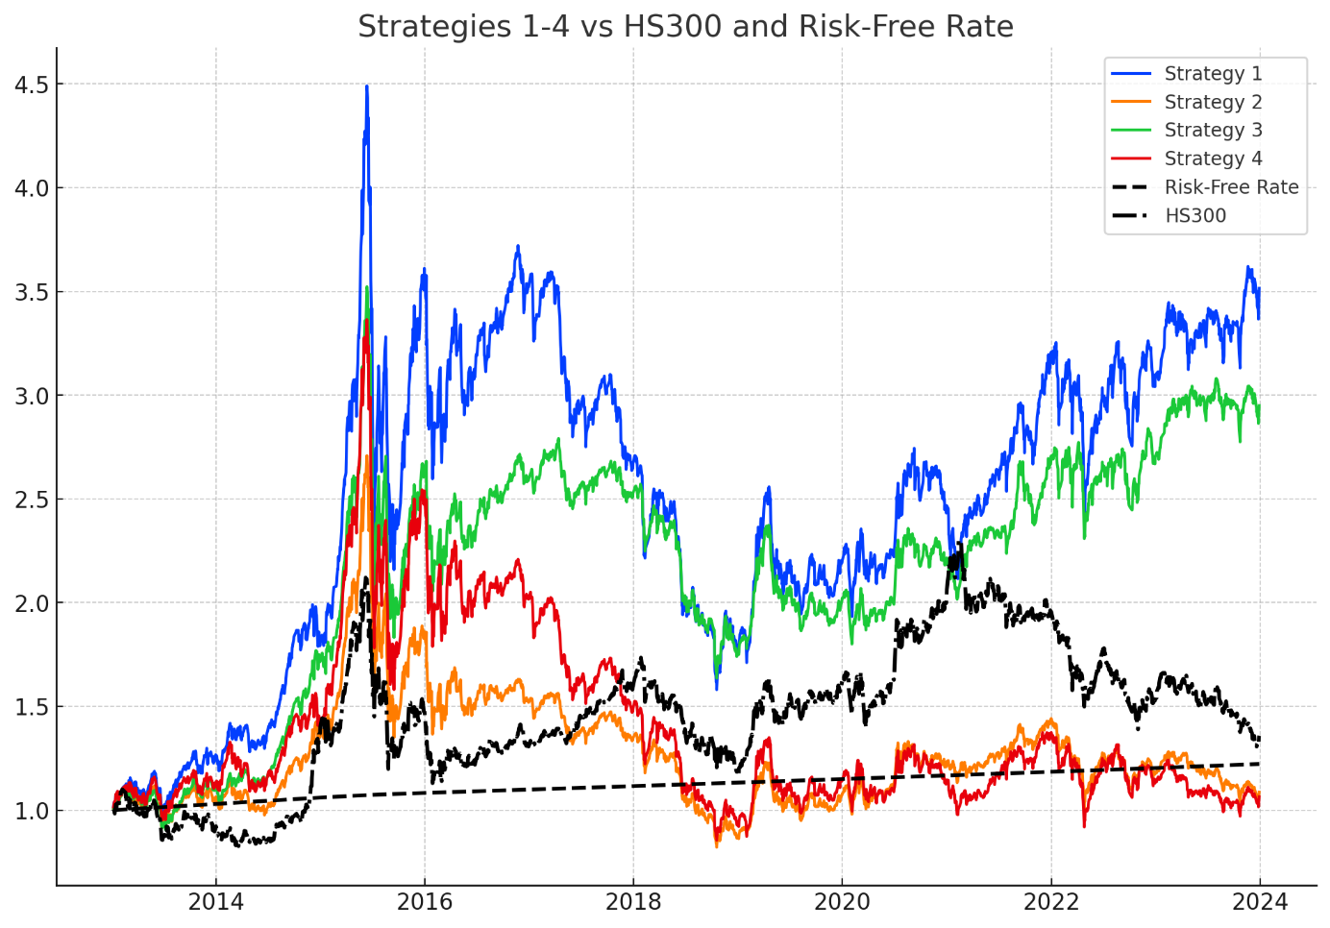Figure 1: Strategies 1-4 vs HS300 and Risk-Free Rate

Figure 1 illustrates the value changes of Strategies 1 through 4 in comparison with the HS300 Index and a risk-free investment. It is evident from the figure that strategies focused on low market capitalization or low volatility have achieved significantly higher performance than the HS300 Index over the observed period. Several factors may contribute to this outperformance:

1. Small-Cap Premium: The small-cap effect, a well-documented phenomenon in financial literature, suggests that firms with lower market capitalization often yield higher returns compared to their larger counterparts. This premium is attributed to the higher growth potential of small firms, which are typically in earlier stages of their growth cycle. Additionally, smaller firms often receive less analyst coverage and are less liquid, leading to pricing inefficiencies that can be exploited by investors. Over the long term, these factors contribute to the superior performance of small-cap strategies.
2. Low Volatility Anomaly: Contrary to the traditional risk-return tradeoff, where higher risk is expected to be compensated with higher returns, the low volatility anomaly posits that stocks with lower volatility tend to offer higher risk-adjusted returns. This anomaly may be explained by investor preferences for stability, especially during periods of market turbulence. As a result, low-volatility stocks, which are perceived as less risky, may attract higher demand, leading to price appreciation and outperformance relative to the broader market.
3. Behavioral Finance Considerations: Behavioral biases, such as overconfidence and the disposition effect, can lead to the overvaluation of high-volatility stocks as investors chase potential high returns. Conversely, low-volatility and small-cap stocks may be undervalued due to their perceived lack of excitement or market attention. When the market corrects these mispricing, strategies that focus on these undervalued segments can yield superior returns. This underlines the importance of behavioral factors in influencing market outcomes and the performance of different investment strategies.
4. Market Inefficiencies: Market inefficiencies are more pronounced in certain segments, particularly among small-cap stocks and those with low volatility. These inefficiencies arise due to factors such as limited analyst coverage, lower liquidity, and the relative obscurity of smaller firms. As a result, prices in these segments may not fully reflect underlying fundamentals, providing opportunities for active investors to achieve abnormal returns. The persistence of these inefficiencies supports the long-term success of strategies that target these market segments.
5. Risk Aversion and Flight to Quality: During periods of economic uncertainty or heightened market volatility, investors tend to become more risk-averse, leading to a flight to quality. In such scenarios, low-volatility stocks and small-cap firms that demonstrate resilience are likely to attract increased investor interest. This shift in investor behavior can drive up the prices of these assets, contributing to their outperformance relative to broader indices like the HS300. The protective characteristics of low-volatility strategies, in particular, become more valuable during such periods, further enhancing their relative performance.

Next, we overlay the market value strategy on top of the volatility strategies in Strategy 3 and Strategy 4. The overlay process follows the sequential sorting and selection method described earlier.

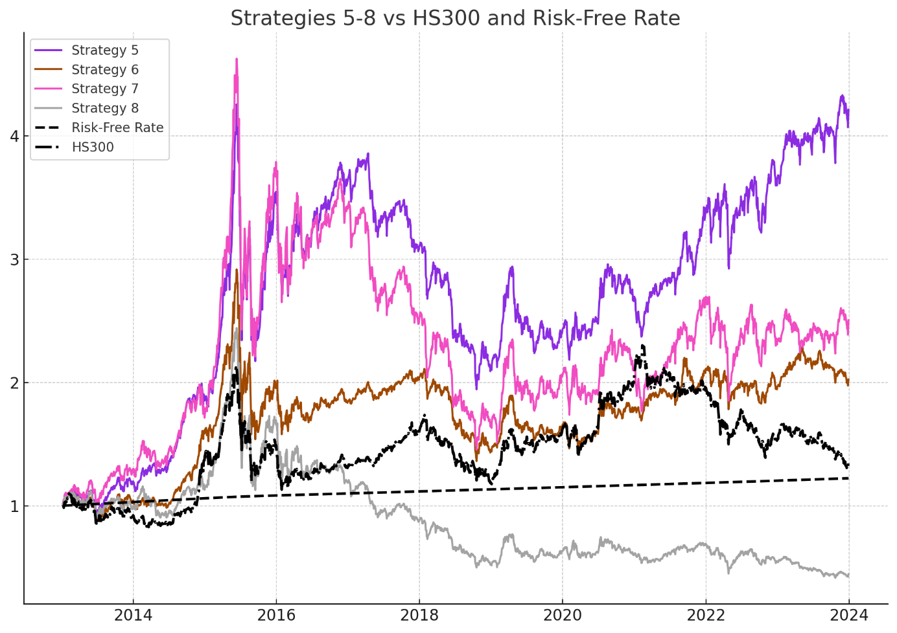

Figure 2: Strategies 5-8 vs HS300 and Risk-Free Rate

The chart in Figure 2 demonstrates that the strategy combining low volatility with low market value delivers the best performance among the strategies analyzed. This result can be attributed to several key factors:

1. Compounding Effects: By combining two distinct strategies that historically provide higher returns—low volatility and low market capitalization—the compounded effect can lead to superior performance. Low-volatility stocks tend to offer stability and steady returns, while low market value (small-cap) stocks often have higher growth potential. When these two factors are combined, the strategy benefits from both stability and growth.
2. Enhanced Risk-Adjusted Returns: Low-volatility stocks are less susceptible to sharp declines during market downturns, which helps preserve capital and reduce drawdowns. When this characteristic is combined with the growth potential of small-cap stocks, the overall risk-adjusted returns improve, making the combined strategy more resilient and profitable over time.
3. Market Inefficiencies: Small-cap stocks are often under-researched and less liquid, leading to potential mispricing. Similarly, low-volatility stocks might be overlooked by more aggressive investors chasing high-risk, high-reward opportunities. The combination strategy takes advantage of these market inefficiencies, capturing undervalued opportunities in both dimensions.
4. Behavioral Aspects: Investors' tendency to overlook smaller and less volatile companies in favor of more prominent, high-risk opportunities creates a niche where disciplined strategies focusing on these attributes can thrive. The consistent demand for stability (low volatility) combined with the growth prospects of small caps leads to outperformance.

Next, we incorporate the growth factor into the combined volatility and market value strategy. This incorporation is achieved by introducing a dividend filter and an EPS year-over-year growth filter at intermediate stages of the selection process.

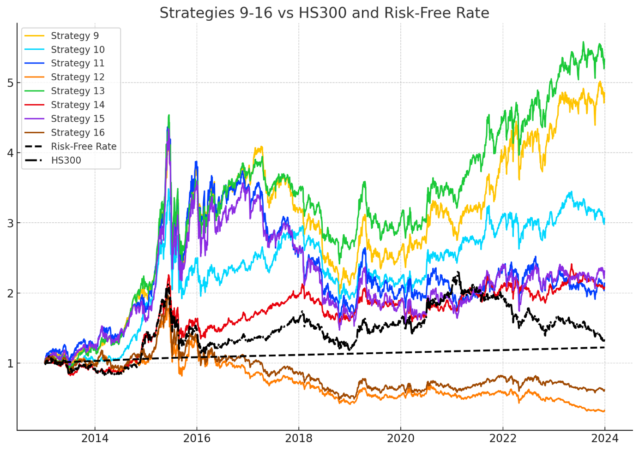

Figure 3: Strategies 9-16 vs HS300 and Risk-Free Rate

Figure 3 demonstrates that the performance of strategies significantly improves after incorporating the growth factor. Notably, the strategies based on low volatility and low market value continue to exhibit the best performance when the growth factor is added. Conversely, it is observed that strategies based on high volatility and high market value perform poorly after the growth factor is integrated.

This divergence in performance can be attributed to several underlying factors:

1. Synergy Between Low Volatility, Low Market Value, and Growth: The combination of low volatility and low market value with growth factors tends to create a portfolio that is both stable and capable of achieving substantial long-term returns. Low volatility stocks are generally less sensitive to market fluctuations and provide consistent returns. When these characteristics are coupled with the growth potential of small-cap stocks, which are inherently more nimble and capable of rapid expansion, the overall portfolio benefits from both stability and upside potential. The growth factor further enhances this dynamic by selecting companies with strong earnings growth, thus reinforcing the already favorable characteristics of low volatility and small-cap stocks.
2. Growth Factor Misalignment with High Volatility and High Market Value: High volatility stocks are often associated with greater uncertainty and speculative trading, which can lead to more erratic performance. When the growth factor is added to a high-volatility strategy, the potential for strong earnings growth may not be sufficient to offset the inherent risks and price swings associated with these stocks. Similarly, large-cap stocks (high market value) are typically more mature and have less room for aggressive growth. The growth factor, which favors companies with rapid earnings expansion, may not align well with the typically slower growth profiles of large-cap companies. This misalignment can lead to suboptimal performance, as the growth factor may not effectively enhance the returns of these already mature and potentially overvalued stocks.
3. Market Expectations and Valuation Concerns: High volatility and high market value stocks are often subject to elevated market expectations and may be priced accordingly. When the growth factor is added, if the expected growth does not materialize or falls short of market expectations, these stocks can suffer significant price declines. The market's tendency to overreact to negative earnings surprises in high-expectation stocks exacerbates this issue, leading to poorer performance for high-volatility and large-cap strategies when combined with the growth factor.
4. Investor Behavior and Risk Preferences: Investors tend to prefer stability during uncertain times, which benefits low-volatility and small-cap strategies. The addition of the growth factor to these strategies may attract further investor interest, driving up prices and enhancing performance. On the other hand, high-volatility and large-cap stocks may be seen as riskier or overvalued when growth prospects are uncertain, leading to underperformance as investors shift away from these segments in favor of more stable or undervalued opportunities.

Table 3 provides a comprehensive overview of the annual returns generated by each strategy alongside the CSI 300 index. This comparison allows for a year-by-year analysis of the performance, highlighting how each strategy has fared relative to the benchmark. The table serves as a fundamental tool for assessing the effectiveness and profitability of the strategies in various market conditions, offering a clear picture of their ability to generate returns over time.

|  |  |  |  |  |  |  |  |  |  |  |  |
| --- | --- | --- | --- | --- | --- | --- | --- | --- | --- | --- | --- |
| **Table 3: Annual Returns of Strategies and HSI 300** | | | | | | | | | | | |
| Strategy | 2013 | 2014 | 2015 | 2016 | 2017 | 2018 | 2019 | 2020 | 2021 | 2022 | 2023 |
| CSI 300 | -0.08 | 0.52 | 0.06 | -0.11 | 0.22 | -0.25 | 0.36 | 0.27 | -0.05 | -0.22 | -0.11 |
| 1 | 0.25 | 0.43 | 0.93 | 0.02 | -0.25 | -0.35 | 0.25 | 0.11 | 0.31 | -0.03 | 0.13 |
| 2 | 0.06 | 0.29 | 0.32 | -0.16 | -0.12 | -0.36 | 0.25 | 0.14 | 0.16 | -0.17 | -0.08 |
| 3 | 0.11 | 0.57 | 0.49 | 0 | -0.04 | -0.31 | 0.16 | 0.09 | 0.23 | 0 | 0.08 |
| 4 | 0.12 | 0.23 | 0.73 | -0.17 | -0.27 | -0.39 | 0.24 | -0.01 | 0.2 | -0.16 | -0.06 |
| 5 | 0.18 | 0.57 | 0.85 | 0.06 | -0.16 | -0.33 | 0.16 | 0.11 | 0.28 | 0.07 | 0.14 |
| 6 | 0.04 | 0.56 | 0.2 | -0.06 | 0.1 | -0.3 | 0.15 | 0.08 | 0.18 | -0.07 | 0.03 |
| 7 | 0.27 | 0.33 | 1.08 | -0.05 | -0.27 | -0.36 | 0.26 | 0.02 | 0.28 | -0.12 | 0.07 |
| 8 | -0.01 | 0.13 | 0.43 | -0.26 | -0.27 | -0.42 | 0.23 | -0.04 | 0.13 | -0.19 | -0.18 |
| 9 | 0.2 | 0.63 | 0.87 | 0.02 | -0.15 | -0.34 | 0.23 | 0.15 | 0.32 | 0.1 | 0.12 |
| 10 | 0.04 | 0.77 | 0.3 | -0.05 | 0.22 | -0.33 | 0.15 | 0.16 | 0.21 | -0.04 | 0.02 |
| 11 | 0.23 | 0.39 | 1.13 | -0.05 | -0.28 | -0.33 | 0.18 | -0.03 | 0.2 | -0.12 | 0.03 |
| 12 | -0.03 | -0.01 | 0.27 | -0.31 | -0.18 | -0.42 | 0.31 | -0.02 | 0.1 | -0.2 | -0.28 |
| 13 | 0.2 | 0.75 | 0.65 | 0.07 | -0.07 | -0.24 | 0.17 | 0.13 | 0.29 | 0.1 | 0.08 |
| 14 | -0.08 | 0.56 | 0.12 | 0 | 0.21 | -0.19 | 0.18 | -0.07 | 0.18 | -0.04 | 0.03 |
| 15 | 0.24 | 0.26 | 1.16 | 0.01 | -0.26 | -0.39 | 0.15 | 0 | 0.29 | -0.09 | 0.05 |
| 16 | -0.03 | 0.1 | 0.24 | -0.22 | -0.19 | -0.42 | 0.35 | -0.04 | 0.26 | -0.1 | -0.14 |

Table 4 presents the Sharpe ratios for each strategy and the CSI 300 index over the examined years. The Sharpe ratio is a critical measure of risk-adjusted return, providing insight into how much return each strategy has generated for each unit of risk taken. By comparing these ratios across strategies, one can evaluate which strategies have offered the best trade-off between risk and return, thus identifying those that have managed to deliver superior returns with lower volatility.

**Table 4: Sharpe Ratios of Strategies and CSI 300**

|  |  |  |  |  |  |  |  |  |  |  |  |
| --- | --- | --- | --- | --- | --- | --- | --- | --- | --- | --- | --- |
| Strategy | 2013 | 2014 | 2015 | 2016 | 2017 | 2018 | 2019 | 2020 | 2021 | 2022 | 2023 |
| CSI 300 | -0.27 | 2.32 | 0.34 | -0.44 | 2.06 | -1.3 | 1.7 | 1.21 | -0.21 | -1.14 | -0.86 |
| 1 | 1.15 | 1.87 | 1.72 | 0.14 | -1.53 | -1.53 | 1.04 | 0.6 | 1.6 | -0.05 | 0.95 |
| 2 | 0.37 | 1.46 | 0.9 | -0.49 | -0.86 | -1.84 | 1.11 | 0.69 | 1.14 | -0.81 | -0.57 |
| 3 | 0.66 | 2.69 | 1.18 | 0.1 | -0.18 | -1.73 | 0.86 | 0.57 | 1.53 | 0.09 | 0.82 |
| 4 | 0.64 | 1.06 | 1.5 | -0.45 | -1.63 | -1.63 | 0.93 | 0.14 | 1.11 | -0.59 | -0.33 |
| 5 | 0.97 | 2.48 | 1.66 | 0.29 | -1.02 | -1.69 | 0.82 | 0.6 | 1.64 | 0.41 | 1.12 |
| 6 | 0.3 | 2.67 | 0.67 | -0.14 | 1.13 | -1.73 | 0.89 | 0.52 | 1.26 | -0.3 | 0.34 |
| 7 | 1.21 | 1.35 | 1.91 | -0.08 | -1.55 | -1.42 | 0.99 | 0.25 | 1.32 | -0.41 | 0.53 |
| 8 | 0.06 | 0.72 | 1.07 | -0.82 | -1.68 | -1.82 | 0.86 | 0.04 | 0.77 | -0.75 | -1.21 |
| 9 | 1.05 | 2.85 | 1.7 | 0.14 | -0.79 | -1.74 | 1.06 | 0.78 | 1.74 | 0.49 | 0.93 |
| 10 | 0.29 | 3.26 | 0.88 | -0.06 | 1.46 | -1.99 | 0.86 | 0.87 | 1.35 | -0.14 | 0.32 |
| 11 | 1.06 | 1.56 | 1.95 | -0.06 | -1.5 | -1.33 | 0.74 | 0.08 | 1.06 | -0.45 | 0.31 |
| 12 | 0 | 0.12 | 0.82 | -1.09 | -0.9 | -1.67 | 1.13 | 0.11 | 0.63 | -0.71 | -1.78 |
| 13 | 1.06 | 2.9 | 1.4 | 0.32 | -0.49 | -1.36 | 0.9 | 0.72 | 1.81 | 0.5 | 0.78 |
| 14 | -0.43 | 2.63 | 0.49 | 0.17 | 2.29 | -1.07 | 1.2 | -0.26 | 1.17 | -0.13 | 0.37 |
| 15 | 1.11 | 1.05 | 2.08 | 0.1 | -1.54 | -1.56 | 0.66 | 0.17 | 1.42 | -0.28 | 0.46 |
| 16 | 0 | 0.55 | 0.74 | -0.68 | -1.02 | -1.83 | 1.21 | 0 | 1.46 | -0.38 | -1.05 |

Table 5 illustrates the maximum drawdowns experienced by each strategy and the CSI 300 index during the period under review. The maximum drawdown represents the largest percentage drop from a peak to a trough, offering a measure of downside risk. By analyzing these figures, the table allows for a direct comparison of the resilience of each strategy in periods of market stress. This comparison is crucial for understanding the potential risks associated with each strategy and the extent of loss that could be encountered in adverse market conditions.

|  |  |  |  |  |  |  |  |  |  |  |  |
| --- | --- | --- | --- | --- | --- | --- | --- | --- | --- | --- | --- |
| **Table 5: Maximum Drawdowns of Strategies and CSI 300** | | | | | | | | | | | |
| Strategy | 2013 | 2014 | 2015 | 2016 | 2017 | 2018 | 2019 | 2020 | 2021 | 2022 | 2023 |
| CSI 300 | -0.22 | -0.1 | -0.43 | -0.19 | -0.06 | -0.32 | -0.13 | -0.16 | -0.18 | -0.29 | -0.22 |
| 1 | -0.17 | -0.1 | -0.52 | -0.27 | -0.27 | -0.42 | -0.24 | -0.15 | -0.14 | -0.25 | -0.09 |
| 2 | -0.19 | -0.15 | -0.5 | -0.26 | -0.16 | -0.4 | -0.23 | -0.14 | -0.09 | -0.29 | -0.19 |
| 3 | -0.18 | -0.07 | -0.48 | -0.23 | -0.12 | -0.36 | -0.21 | -0.13 | -0.11 | -0.17 | -0.1 |
| 4 | -0.18 | -0.18 | -0.53 | -0.28 | -0.28 | -0.44 | -0.27 | -0.17 | -0.15 | -0.32 | -0.22 |
| 5 | -0.18 | -0.09 | -0.49 | -0.25 | -0.21 | -0.38 | -0.24 | -0.13 | -0.11 | -0.19 | -0.09 |
| 6 | -0.19 | -0.08 | -0.47 | -0.22 | -0.07 | -0.35 | -0.19 | -0.13 | -0.13 | -0.16 | -0.14 |
| 7 | -0.17 | -0.15 | -0.52 | -0.29 | -0.29 | -0.43 | -0.25 | -0.18 | -0.16 | -0.31 | -0.14 |
| 8 | -0.2 | -0.22 | -0.54 | -0.29 | -0.28 | -0.45 | -0.29 | -0.2 | -0.13 | -0.34 | -0.29 |
| 9 | -0.17 | -0.08 | -0.48 | -0.24 | -0.23 | -0.38 | -0.25 | -0.12 | -0.11 | -0.19 | -0.11 |
| 10 | -0.16 | -0.06 | -0.45 | -0.22 | -0.14 | -0.37 | -0.21 | -0.12 | -0.14 | -0.17 | -0.14 |
| 11 | -0.19 | -0.13 | -0.5 | -0.26 | -0.3 | -0.4 | -0.28 | -0.16 | -0.13 | -0.24 | -0.18 |
| 12 | -0.19 | -0.27 | -0.54 | -0.34 | -0.22 | -0.44 | -0.27 | -0.26 | -0.14 | -0.32 | -0.39 |
| 13 | -0.17 | -0.1 | -0.47 | -0.22 | -0.15 | -0.31 | -0.23 | -0.13 | -0.12 | -0.16 | -0.09 |
| 14 | -0.22 | -0.09 | -0.42 | -0.18 | -0.05 | -0.29 | -0.14 | -0.17 | -0.15 | -0.17 | -0.15 |
| 15 | -0.18 | -0.17 | -0.5 | -0.29 | -0.27 | -0.45 | -0.27 | -0.2 | -0.12 | -0.28 | -0.14 |
| 16 | -0.22 | -0.24 | -0.48 | -0.29 | -0.23 | -0.45 | -0.26 | -0.18 | -0.1 | -0.27 | -0.22 |

Table 6 summarizes the annual average values of key performance metrics for each strategy and the CSI 300 index. This summary provides a clear picture of the consistency and overall quality of the strategies over the years.

|  |  |  |  |
| --- | --- | --- | --- |
| **Table 6: Annual Average Values of Key Metrics for Strategies and CSI 300** | | | |
| Strategy | Average Return | Average Sharpe Ratio | Average Maximum Drawdown |
| CSI 300 | 0.06 | 0.31 | -0.21 |
| 1 | 0.16 | 0.54 | -0.24 |
| 2 | 0.03 | 0.10 | -0.24 |
| 3 | 0.13 | 0.60 | -0.20 |
| 4 | 0.04 | 0.07 | -0.27 |
| 5 | 0.18 | 0.66 | -0.21 |
| 6 | 0.08 | 0.51 | -0.19 |
| 7 | 0.14 | 0.37 | -0.26 |
| 8 | -0.04 | -0.25 | -0.29 |
| 9 | 0.20 | 0.75 | -0.21 |
| 10 | 0.13 | 0.65 | -0.20 |
| 11 | 0.12 | 0.31 | -0.25 |
| 12 | -0.07 | -0.30 | -0.31 |
| 13 | 0.19 | 0.78 | -0.20 |
| 14 | 0.08 | 0.58 | -0.18 |
| 15 | 0.13 | 0.33 | -0.26 |
| 16 | -0.02 | -0.09 | -0.27 |

Table 7 presents the cumulative performance of key metrics over the entire period. This table illustrates the total returns, overall Sharpe ratios, and maximum drawdowns, offering a comprehensive perspective on the long-term performance and risk profile of each strategy.

|  |  |  |  |
| --- | --- | --- | --- |
| **Table 7: Cumulative Performance of Key Metrics for Strategies and CSI 300** | | | |
| Strategy | Cumulative Return | Overall Sharpe Ratio | Maximum Drawdown (Period) |
| CSI 300 | 0.36 | 0.24 | -0.47 |
| 1 | 2.46 | 0.58 | -0.65 |
| 2 | 0.08 | 0.15 | -0.7 |
| 3 | 1.92 | 0.56 | -0.54 |
| 4 | 0.05 | 0.16 | -0.75 |
| 5 | 3.16 | 0.68 | -0.54 |
| 6 | 1.01 | 0.41 | -0.53 |
| 7 | 1.45 | 0.44 | -0.69 |
| 8 | -0.56 | -0.13 | -0.83 |
| 9 | 3.79 | 0.73 | -0.54 |
| 10 | 2.02 | 0.58 | -0.47 |
| 11 | 1.1 | 0.39 | -0.64 |
| 12 | -0.68 | -0.23 | -0.83 |
| 13 | 4.3 | 0.79 | -0.47 |
| 14 | 1.07 | 0.44 | -0.42 |
| 15 | 1.27 | 0.42 | -0.66 |
| 16 | -0.39 | -0.03 | -0.76 |

Strategy 13 consistently emerges as the top-performing strategy across multiple metrics. This strategy is characterized by its focus on small-cap stocks with low volatility and high growth potential, a combination that has proven to be particularly effective in the context of the Chinese stock market.

Average Return (Table 6):

Strategy 13 achieves the highest average return of 0.19, significantly outperforming other strategies. This suggests that small-cap stocks, when selected based on low volatility and high growth criteria, tend to provide superior returns on an annual basis. The focus on growth potential within a stable, low-volatility environment allows this strategy to capitalize on the upward momentum of smaller companies without being subjected to the high risks typically associated with such investments.

Average Sharpe Ratio (Table 6):

The average Sharpe ratio for Strategy 13 stands at 0.78, the highest among all strategies analyzed. This indicates that the strategy not only delivers high returns but does so with a favorable risk-return profile. The high Sharpe ratio reflects the strategy’s ability to generate returns that are significantly greater than the level of risk taken, making it an attractive option for risk-averse investors seeking growth.

Average Maximum Drawdown (Table 6):

Although not the lowest in terms of drawdown, Strategy 13 maintains a reasonable average maximum drawdown. This demonstrates that while the strategy does take on some risk, it effectively manages downside exposure, ensuring that losses during market downturns are kept within manageable limits.

Cumulative Return (Table 7):

Over the study period, Strategy 13 achieves a cumulative return of 4.3, the highest among all strategies. This long-term performance further solidifies the strategy’s effectiveness, showing that its superior annual returns compound to deliver significant wealth accumulation over time. The strategy’s emphasis on stable, high-growth small-cap stocks enables it to outperform more traditional approaches, including the CSI 300 index.

Overall Sharpe Ratio (Table 7):

The overall Sharpe ratio for Strategy 13 remains the highest at 0.79, confirming that the strategy provides the best risk-adjusted returns over the entire period. This consistency in performance underscores the strategy’s robustness, making it a reliable choice for long-term investment.

Maximum Drawdown (Period) (Table 7):

The maximum drawdown for Strategy 13 is moderate, reflecting the strategy’s ability to protect capital during market downturns. While other strategies, such as Strategy 14 (which focuses on low-volatility, high-dividend large-cap stocks), may offer slightly better protection against drawdowns, Strategy 13 balances this risk with much higher returns, making it the more compelling option overall.

While Strategy 13 is the clear leader, other strategies also show noteworthy performance:

Strategy 9 (smallest 20% by volatility, highest 20% by growth rate, and smallest 50% by market value) and Strategy 5 (smallest 20% by volatility and smallest 50% by market value) both demonstrate strong average returns and Sharpe ratios. These strategies confirm the effectiveness of combining low volatility with growth-oriented small-cap stocks. However, they fall short of the cumulative returns and overall Sharpe ratio achieved by Strategy 13.

Strategy 14, which focuses on the smallest 20% by volatility, highest 20% by dividend yield, and largest 50% by market value, shows the lowest maximum drawdown, making it an excellent choice for risk-averse investors prioritizing capital preservation. However, its returns are lower than those of Strategy 13, making it less attractive for those seeking growth.

Strategies emphasizing high volatility, such as Strategies 8 and 12, generally underperform. These strategies exhibit lower average returns and Sharpe ratios, coupled with higher maximum drawdowns. This suggests that while high volatility might offer potential for short-term gains, it often leads to inconsistent performance and increased risk over the long term.

When compared to the CSI 300 index, Strategy 13 and several other low-volatility strategies clearly outperform the market benchmark:

The CSI 300’s cumulative return of 0.36 and overall Sharpe ratio of 0.24 are modest relative to the performance of Strategy 13. This indicates that the broader market, while more diversified, does not capture the full potential of smaller, growth-oriented, low-volatility stocks.

The CSI 300’s maximum drawdown is -0.47%, which is relatively moderate but not as favorable as the drawdowns managed by the best-performing strategies in this analysis. This suggests that the CSI 300 may expose investors to more downside risk than carefully selected low-volatility strategies.

The analysis of Tables 5.4 and 5.5 clearly identifies Strategy 13 as the most effective low-volatility strategy in the Chinese stock market. By focusing on small-cap stocks with low volatility and high growth potential, this strategy consistently delivers superior returns, both on an annual basis and cumulatively over the study period. Its high Sharpe ratio further emphasizes the strategy’s ability to generate returns while managing risk effectively.

In comparison to the broader market, as represented by the CSI 300 index, Strategy 13 and similar strategies not only outperform in terms of returns but also offer better protection against market downturns. This demonstrates the value of a targeted, low-volatility approach in achieving long-term investment success in the Chinese equity market.

**4.2 Investment Portfolio Industry Composition Analysis**

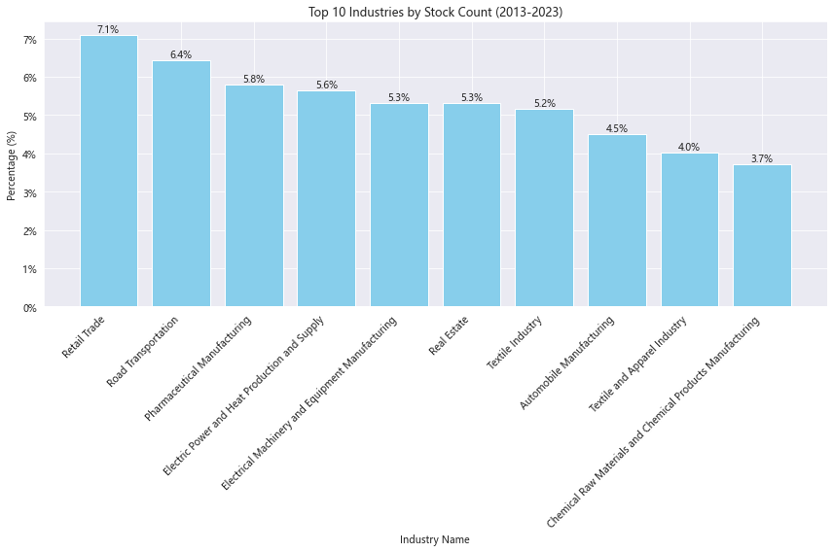

Figure 4: Top 10 Industries by Stock Count (2013-2023)

Figure 4 illustrates the distribution of the top ten industries within Strategy 13, the best-performing low volatility approach from 2013 to 2023. The chart highlights the sectors where the strategy found the most alignment with its objectives.

Retail Trade leads the distribution, making up 7.1% of the portfolio, indicating that retail companies frequently matched the strategy's focus on stability and yield. Road Transportation follows with a 6.4% share, suggesting that companies in this sector also consistently met the strategy's criteria.

Other significant sectors include Pharmaceutical Manufacturing (5.8%) and Electric Power and Heat Production and Supply (5.6%), both known for their defensive characteristics and steady earnings. Electrical Machinery and Equipment Manufacturing (5.3%) and Real Estate (5.3%) also feature prominently, reflecting their capacity for providing consistent returns.

The inclusion of Textile Industry (5.2%) and Automobile Manufacturing (4.5%) among the top ten further demonstrates the strategy's effectiveness in identifying value across various sectors, including those with cyclical elements.

**4.3 Market Environment Analysis**

Table 8 presents the annual performance of Strategy 13 from 2013 to 2023, comparing its returns against the CSI 300 Index across different market conditions (upward and downward markets). It highlights key metrics such as excess return and capture ratio, illustrating how the strategy performed relative to the benchmark each year.

|  |  |  |  |  |  |
| --- | --- | --- | --- | --- | --- |
| **Table 8: Performance of Strategy 13 in Upward and Downward Markets (2013-2023)** | | | | | |
| Year | Strategy 13 Annual Return (%) | CSI 300 Annual Return (%) | Market Condition | Excess Return (%) | Capture Ratio (%) |
| 2013 | 20.46 | -8.12 | Downward Market | 28.58 | -251.95 |
| 2014 | 75.49 | 54.26 | Upward Market | 21.23 | 139.13 |
| 2015 | 65.5 | 2.47 | Upward Market | 63.03 | 2651.38 |
| 2016 | 6.56 | -4.85 | Downward Market | 11.41 | -135.32 |
| 2017 | -7.34 | 19.67 | Upward Market | -27.01 | -37.29 |
| 2018 | -24.36 | -26.77 | Downward Market | 2.41 | 91 |
| 2019 | 16.65 | 38.17 | Upward Market | -21.52 | 43.63 |
| 2020 | 12.98 | 25.73 | Upward Market | -12.75 | 50.45 |
| 2021 | 29.01 | -7.97 | Downward Market | 36.99 | -363.77 |
| 2022 | 9.64 | -20.47 | Downward Market | 30.11 | -47.09 |
| 2023 | 8.3 | -11.86 | Downward Market | 20.17 | -70 |

Table 9 summarizes the average performance of Strategy 13 in both upward and downward markets, providing a concise overview of the strategy's overall effectiveness. The table includes metrics such as average excess return, win rate, and average capture ratio, offering insights into the strategy's consistent performance across varying market conditions.

|  |  |
| --- | --- |
| **Table 9: Average Performance of Strategy 13 in Upward and Downward Markets** | |
| Metric | Value |
| Average Excess Return in Upward Market (%) | 4.596 |
| Average Excess Return in Downward Market (%) | 21.61167 |
| Win Rate in Upward Market (%) | 40 |
| Win Rate in Downward Market (%) | 100 |
| Average Upward Capture Ratio (%) | 569.46 |
| Average Downward Capture Ratio (%) | -129.522 |

Overview of Strategy 13 Performance:

Strategy 13 employs a filtering mechanism that first selects stocks with the lowest volatility (bottom 20%), then screens for the highest dividend yields (top 20%), and finally narrows down to the smallest market capitalizations (bottom 50%). The table above highlights the strategy's performance across various market conditions from 2013 to 2023, revealing distinct patterns in both upward and downward markets.

Upward Market Performance:

Strategy 13 exhibited an exceptionally high capture ratio in upward markets, averaging 569.46% across the analyzed period. This indicates that the strategy consistently outperformed the CSI 300 Index during market upswings, often by a significant margin. The standout year is 2015, where Strategy 13 achieved a return of 65.50%, compared to the CSI 300's mere 2.47%. This led to an extraordinary capture ratio of 2651.38%, which significantly inflated the average capture ratio for upward markets.

The 2015 performance can be attributed to several macroeconomic factors. In 2015, the Chinese stock market experienced significant volatility, driven by speculative trading and a subsequent market crash. During the recovery phase, government intervention and monetary easing bolstered investor confidence, particularly in stable, dividend-paying, and smaller-cap stocks, which Strategy 13 favored. The low volatility and high dividend characteristics of the selected stocks made them attractive during the market's stabilization period, resulting in substantial gains for the strategy.

However, it's important to note that while Strategy 13 thrived in 2015, its performance in other upward markets, such as in 2017, 2019, and 2020, was less impressive. In these years, the strategy's excess returns were negative, and the capture ratios were significantly lower. This variability suggests that the strategy is highly sensitive to specific market conditions, particularly those involving rapid recovery or significant policy interventions.

Downward Market Performance:

In downward markets, Strategy 13 demonstrated a distinctive capability to achieve positive returns, reflected in its average capture ratio of -129.52%. This negative capture ratio indicates that the strategy often produced gains even when the market was declining, showcasing its defensive strengths.

The year 2021 is particularly noteworthy, where Strategy 13 delivered a return of 29.01%, against a CSI 300 loss of -7.97%. This resulted in a capture ratio of -363.77%, the highest (in absolute terms) across all years. The strategy's success in 2021 can be linked to its focus on low-volatility and high-dividend stocks, which were in high demand as investors sought safer havens amidst economic uncertainty caused by the COVID-19 pandemic and tightening regulatory policies in China.

The macroeconomic backdrop of 2021 featured ongoing global disruptions due to the pandemic, alongside specific challenges within China, such as the crackdown on technology companies and the real estate sector's deleveraging efforts. These factors created a flight to safety, where investors gravitated towards stable, dividend-yielding stocks, often found in smaller, less volatile companies. Strategy 13 capitalized on this shift, leading to its strong performance despite broader market declines.

The Role of Strategy 13:

Strategy 13's performance highlights its dual role as both a defensive and opportunistic investment strategy. In upward markets, particularly those marked by volatility or policy-driven recoveries, the strategy's focus on stable, high-dividend, small-cap stocks allows it to capture outsized returns. Conversely, in downward markets, Strategy 13's defensive characteristics come to the fore, enabling it to not only protect capital but often deliver positive returns when broader indices are in decline.

The strategy's emphasis on low volatility and high dividends provides a buffer against market downturns, while its small-cap orientation offers growth potential during market recoveries. However, the strategy's performance is not uniform across all market conditions; it thrives particularly well in environments where macroeconomic policies favor stability and where market participants seek safety in dividend-paying stocks.

Investors using Strategy 13 should be mindful of its sensitivity to specific market conditions. While the strategy has proven effective in both protecting capital during downturns and generating substantial returns during market recoveries, its reliance on specific market dynamics—such as those seen in 2015 and 2021—means that its performance can vary significantly depending on the broader economic and market environment.

In summary, Strategy 13 is a robust tool for navigating both bull and bear markets, offering a balanced approach that combines growth potential with defensive stability. Its performance across the 2013-2023 period underscores its ability to adapt to varying market conditions, making it a valuable component of a diversified investment portfolio.

**4.4 Attribute factors to optimize the strategy**

|  |  |  |  |  |  |  |
| --- | --- | --- | --- | --- | --- | --- |
| **Table 10: OLS Regression Results** | | | | | | |
| Dep. Variable: | Return | R-squared (uncentered): | 0.115 |  |  |  |
| Model: | OLS | Adj. R-squared (uncentered): | 0.109 |  |  |  |
| Method: | Least Squares | F-statistic: | 20.29 |  |  |  |
| Date: | Fri, 16 Aug 2024 | Prob (F-statistic): | 2.23E-12 |  |  |  |
| Time: | 10:09:12 | Log-Likelihood: | -149.93 |  |  |  |
| No. Observations: | 473 | AIC: | 305.9 |  |  |  |
| Df Residuals: | 470 | BIC: | 318.3 |  |  |  |
| Df Model: | 3 |  |  |  |  |  |
| Covariance Type: | Non-robust |  |  |  |  |  |
|  | coef | std err | t | P>|t| | [0.025 | 0.975] |
| const | 0 | 0 | nan | nan | 0 | 0 |
| Log_Market Capitalization | -0.1022 | 0.016 | -6.584 | 0 | -0.133 | -0.072 |
| Log_Volatility | 0.0457 | 0.015 | 2.959 | 0.003 | 0.015 | 0.076 |
| Log_Dividend Yield | 0.0424 | 0.016 | 2.736 | 0.006 | 0.012 | 0.073 |
| Omnibus: | 49.306 | Durbin-Watson: | 1.668 |  |  |  |
| Prob (Omnibus): | 0 | Jarque-Bera (JB): | 67.196 |  |  |  |
| Skew: | 0.759 | Prob (JB): | 2.56E-15 |  |  |  |
| Kurtosis: | 4.05 | Cond. No. | inf |  |  |  |
| Notes:[1] R² is computed without centering (uncentered) since the model does not contain a constant.[2] Standard Errors assume that the covariance matrix of the errors is correctly specified.[3] The smallest eigenvalue is 0. This might indicate that there are strong multicollinearity problems or that the design matrix is singular. | | | | | | |

The Table 10 provides evidence that the returns of our portfolio strategy are significantly influenced by market capitalization, volatility, and dividend yield. Specifically, the negative coefficient for market capitalization indicates that smaller-cap stocks tend to generate higher returns, while the positive coefficients for volatility and dividend yield suggest that higher returns are associated with stocks exhibiting greater volatility and higher dividend payouts. These results align with the strategic rationale underpinning our portfolio construction, where the systematic selection of stocks based on these factors has led to notable performance gains during the study period.

Although the OLS regression confirms the effectiveness of our current strategy by highlighting the significant impact of these factors on portfolio returns, it is primarily a validation tool that captures the linear relationships between individual factors and returns. Given that our strategy has already demonstrated strong performance, our focus now shifts to further refining this approach by identifying which factors most effectively enhance returns while simultaneously minimizing risk, particularly in the context of drawdowns.

To achieve this, we employ a Random Forest algorithm to model the relationship between a broader set of factors and portfolio performance. The Random Forest method is particularly well-suited for this analysis due to its ability to handle complex interactions and non-linear relationships between variables—dynamics that are often present in financial markets. By assessing the relative importance of each factor through this technique, we aim to gain a deeper understanding of which factors are most influential in optimizing our portfolio strategy.

The application of the Random Forest algorithm serves a dual purpose: it allows us to rank the factors in terms of their contribution to maximizing returns, and it also helps us identify the factors that are most effective in mitigating risk, specifically in reducing drawdowns. This analysis is not intended to replace our current strategy, but rather to enhance it by providing a more nuanced understanding of the underlying drivers of portfolio performance. By identifying and prioritizing the most critical factors, we can make targeted adjustments to our strategy that reinforce its robustness and effectiveness in delivering superior risk-adjusted returns.

Furthermore, the Random Forest approach enables us to explore potential interactions between factors that may not be fully captured by a linear regression model. For example, the interplay between market capitalization and volatility may reveal additional insights into how smaller, more volatile stocks contribute to overall portfolio performance. Understanding these interactions allows us to refine our strategy in a way that more accurately reflects the complex realities of market behavior.

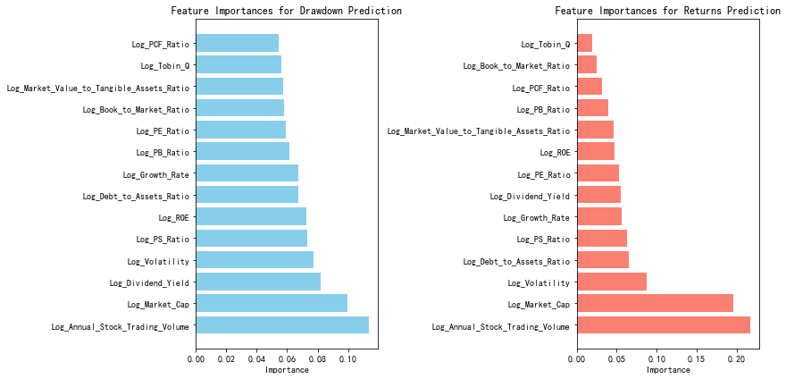

Figure 5: Random Forest Analysis of Factor Importance on Returns and Maximum Drawdown

Figure 5 suggests that annual trading volume plays a critical role in enhancing returns while simultaneously reducing drawdown risk. The centrality of this factor highlights the value of incorporating stocks with higher trading volumes into the portfolio, as these stocks have historically contributed to both stronger returns and greater resilience during market downturns.

In addition, the importance of the low volatility factor, which also ranks highly, further validates the foundation of our strategy. The analysis confirms that the strategy’s success is partly driven by its focus on low volatility stocks, which tend to offer a more favorable balance between risk and return.

Given these findings, we will refine Strategy 13 by focusing on the "Log_Annual_Stock_Trading_Volume" factor. Specifically, we will narrow the stock selection to those that rank in the top 50% based on this factor. By emphasizing stocks with higher trading volumes, the aim is to further enhance the strategy's performance, ensuring it is both robust and effective in delivering superior risk-adjusted returns.

Figure 6 illustrates the cumulative performance of two investment strategies, "Strategy 13" and the "Optimized Strategy," in comparison to the standardized HS300 Index and the accumulated value of the risk-free rate over the period from 2013 to 2023.

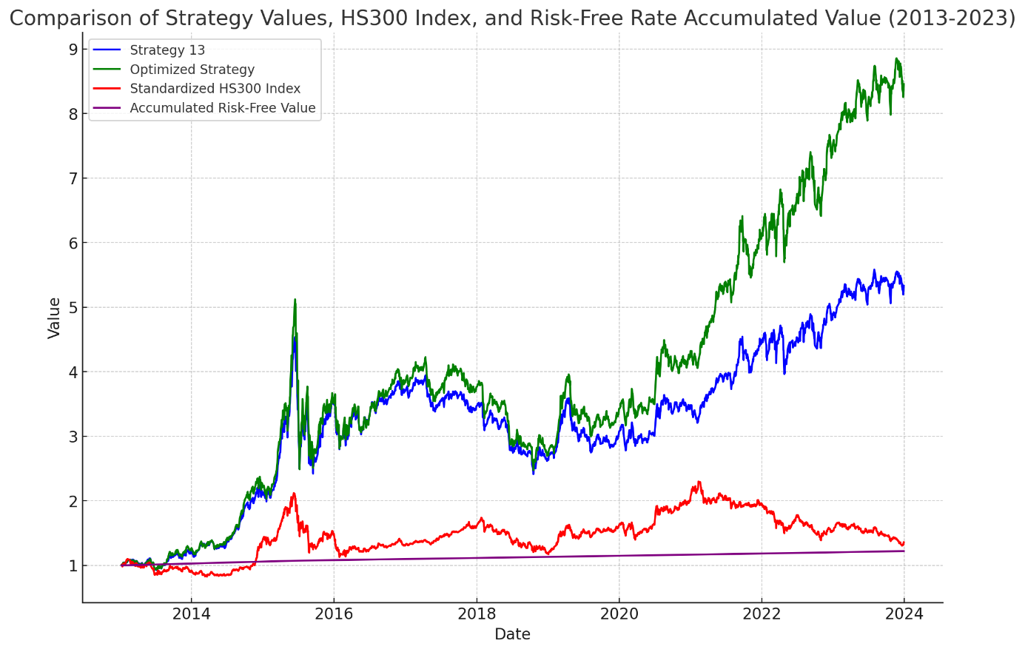

Figure 6: Comparison Of Strategy Values, HS300 Index, And Risk-Free Rate Accumulated Value (2013-2023)

Tables 11-13 present a comprehensive comparative analysis of two investment strategies, namely "Strategy 13" and the "Optimized Strategy," over the period from 2013 to 2023. These tables focus on three critical performance metrics: Annual Return, Maximum Drawdown, and Sharpe Ratio.

|  |  |  |
| --- | --- | --- |
| **Table 11: Annual Return Comparison** | | |
| Year | Strategy 13 Annual Return | Optimized Strategy Annual Return |
| 2013 | 0.204617 | 0.262325 |
| 2014 | 0.75488 | 0.772764 |
| 2015 | 0.654978 | 0.578039 |
| 2016 | 0.06562 | 0.099218 |
| 2017 | -0.07335 | -0.03398 |
| 2018 | -0.24364 | -0.28119 |
| 2019 | 0.166532 | 0.265491 |
| 2020 | 0.129795 | 0.259075 |
| 2021 | 0.290104 | 0.423211 |
| 2022 | 0.096391 | 0.23011 |
| 2023 | 0.083042 | 0.113785 |
| Average | 0.193543 | 0.244441 |
| 2013-2023 | 4.299217 | 7.403435 |

|  |  |  |
| --- | --- | --- |
| **Table 12: Sharpe Ratio Comparison** | | |
| Year | Strategy 13 Sharpe Ratio | Optimized Strategy Sharpe Ratio |
| 2013 | 1.064691 | 1.25174 |
| 2014 | 2.947357 | 2.83867 |
| 2015 | 1.382042 | 1.180823 |
| 2016 | 0.376723 | 0.478732 |
| 2017 | -0.55127 | -0.14719 |
| 2018 | -1.39404 | -1.44282 |
| 2019 | 0.901023 | 1.186201 |
| 2020 | 0.708864 | 1.166344 |
| 2021 | 1.813557 | 2.107463 |
| 2022 | 0.539508 | 0.994322 |
| 2023 | 0.718911 | 0.912216 |
| Average | 0.773397 | 0.956955 |
| 2013-2023 | 0.792285 | 0.905977 |

|  |  |  |
| --- | --- | --- |
| **Table 13: Maximum Drawdown Comparison** | | |
| Year | Strategy 13 Max Drawdown | Optimized Strategy Max Drawdown |
| 2013 | -0.16959 | -0.15281 |
| 2014 | -0.09829 | -0.0991 |
| 2015 | -0.46623 | -0.51407 |
| 2016 | -0.22082 | -0.23037 |
| 2017 | -0.14542 | -0.16211 |
| 2018 | -0.31425 | -0.35807 |
| 2019 | -0.23365 | -0.24274 |
| 2020 | -0.12528 | -0.12048 |
| 2021 | -0.12255 | -0.14886 |
| 2022 | -0.15954 | -0.16522 |
| 2023 | -0.09334 | -0.08666 |
| Average | -0.19536 | -0.20732 |
| 2013-2023 | -0.4681 | -0.51654 |

Figure 6 presents a comparative analysis of the cumulative performance of "Strategy 13" and the "Optimized Strategy" over the period from 2013 to 2023, alongside the standardized HS300 Index and the accumulated value of the risk-free rate. The Optimized Strategy, depicted by the green line, consistently outperformed Strategy 13 in terms of cumulative returns, particularly noticeable from 2019 onward.

The objective of the optimization was to enhance returns while mitigating risk, specifically by reducing the maximum drawdown. Although Table 12 (Maximum Drawdown Comparison) indicates that the Optimized Strategy did not achieve a significant reduction in maximum drawdown relative to Strategy 13, the difference between them is minimal. For instance, in 2015, the Optimized Strategy exhibited a maximum drawdown of -51.41%, which is slightly higher than the -46.62% drawdown experienced by Strategy 13. Despite not achieving a substantial decrease in drawdown, the strategy managed to maintain a comparable level of risk, which is a noteworthy outcome.

Importantly, the optimization process significantly improved overall returns, as demonstrated in Table 11 (Annual Return Comparison). The Optimized Strategy consistently delivered higher annual returns across most of the observed years. Moreover, Table 13 (Sharpe Ratio Comparison) shows that the Optimized Strategy achieved superior risk-adjusted returns, as evidenced by higher Sharpe Ratios compared to Strategy 13. For instance, in 2016, the Optimized Strategy attained a Sharpe Ratio of 0.48, compared to 0.38 for Strategy 13, indicating that the optimization effectively enhanced the strategy’s efficiency in generating returns relative to the risk taken.

The performance of the strategies must also be understood within the broader macroeconomic context of the period from 2013 to 2023, which was marked by significant global economic events and varying market conditions:

1. 2013-2015: Slower Growth and Market Volatility

During these years, the global economy, particularly in China, experienced slower growth, and market volatility increased due to factors such as the tightening of U.S. monetary policy. The sharp market correction in 2015 led to substantial drawdowns for both strategies, as reflected in Table 12. However, the Optimized Strategy managed to maintain a drawdown level close to that of Strategy 13, while setting the stage for a stronger recovery in subsequent years.

1. 2016-2018: Economic Stabilization

The global economic environment stabilized, supported by accommodative monetary policies. This period saw the Optimized Strategy outperform Strategy 13, delivering better risk-adjusted returns as indicated by the higher Sharpe Ratios. The strategy capitalized on the recovering markets, reflecting its enhanced capability to balance return and risk during periods of economic growth.

1. 2019-2021: Trade Tensions and Pandemic Impact

The onset of the U.S.-China trade tensions and the global COVID-19 pandemic in 2020 created a volatile market environment. Despite these challenges, the Optimized Strategy continued to outperform, as shown by the pronounced divergence from Strategy 13 in Figure 6. The strategy’s ability to adapt to these disruptions and benefit from the subsequent recovery, supported by significant global stimulus measures, is evident in its superior returns and higher Sharpe Ratios.

1. 2022-2023: Inflation and Market Adjustments

In response to rising inflation, central banks, including the Federal Reserve, began tightening monetary policies, which led to market adjustments. Even in this challenging environment, the Optimized Strategy maintained its outperformance, continuing to deliver returns that outpaced both Strategy 13 and the HS300 Index, while preserving a favorable risk-return balance as shown by its Sharpe Ratio.

while the Optimized Strategy did not achieve a substantial reduction in maximum drawdown relative to Strategy 13, the optimization was successful in maintaining a comparable risk profile while significantly improving overall returns. The substantial increase in both annual returns and Sharpe Ratios highlights the effectiveness of the optimization in enhancing the strategy’s performance. Moreover, the Optimized Strategy demonstrated robustness across various macroeconomic conditions, effectively managing risks while capitalizing on opportunities for growth. This makes the Optimized Strategy a compelling option for investors who seek higher returns without proportionately increasing risk, achieving a balanced approach to performance and risk management.

**4.5 limitations**

One significant limitation of this study is related to data availability and quality. The analysis is based on data from 2013 to 2023, which may not fully capture long-term trends in the Chinese stock market. The reliability of financial indicators such as EPS growth and market capitalization depends on the accuracy of the data sources. Any inaccuracies or inconsistencies in these data could potentially influence the study's outcomes.

Another limitation lies in the study’s market-specific focus on the Shanghai and Shenzhen A-share markets. These markets are known for their high volatility and the substantial influence of retail investors. While this focus provides valuable insights into the behavior of low-volatility strategies within these particular markets, the findings may not be applicable to other markets with different structural characteristics, such as those dominated by institutional investors.

The results are also influenced by the economic and market conditions during the study period, which included events like the COVID-19 pandemic and U.S.-China trade tensions. These specific conditions may limit the generalizability of the findings to other periods with different economic dynamics. Additionally, the frequent regulatory changes in China could affect the consistency of the strategies' performance in future or different regulatory environments.

Finally, there is a potential risk of overfitting due to the use of sophisticated machine learning techniques like the Random Forest algorithm. These methods, while powerful, may tailor the model too closely to the specific dataset used, potentially reducing its effectiveness when applied to new or unseen data. The study’s lack of extensive out-of-sample testing further constrains the assessment of the strategies' robustness across different time periods and market conditions.

1. **Conclusion**

Based on the analysis conducted, this study has provided valuable insights into the performance and optimization of low-volatility investment strategies within the Chinese stock market, particularly focusing on the Shanghai and Shenzhen A-shares over an eleven-year period from 2013 to 2023. The findings indicate that low-volatility strategies, especially when combined with small-cap stocks and growth factors such as EPS growth and dividend yield, consistently outperform higher-volatility strategies and the broader market, as represented by the CSI 300 index.

The empirical results demonstrate that Strategy 13, which emphasizes small-cap stocks with low volatility and high growth potential, achieves superior risk-adjusted returns and exhibits strong resilience during market downturns. The application of advanced methodologies, including the Random Forest algorithm, has further enhanced the strategy’s performance by optimizing the stock selection process and identifying the most influential factors, such as trading volume and volatility. The optimized strategy has not only delivered higher cumulative returns but also improved risk-adjusted performance, as evidenced by higher Sharpe ratios.

Nevertheless, the study acknowledges several limitations. These include data constraints, the market-specific focus on the Chinese A-shares, and the potential risk of overfitting due to the use of advanced machine learning techniques. These limitations may affect the generalizability of the findings and suggest areas for future research, such as extending the analysis to other markets or incorporating out-of-sample testing to further validate the robustness of the strategies.

In conclusion, this research contributes to the understanding of low-volatility investment strategies within the context of an emerging market like China. The findings provide practical implications for portfolio managers, institutional investors, and policymakers, highlighting that a well-constructed low-volatility strategy, particularly one that integrates growth factors, can offer superior risk-adjusted returns and effective risk management in the Chinese stock market.

1. **References**

[Ang, A., Hodrick, R. J., Xing, Y., & Zhang, X. (2006). The Cross-Section of Volatility and Expected Returns. The Journal of Finance, 61(1), 259-299.](https://onlinelibrary.wiley.com/doi/10.1111/j.1540-6261.2006.00836.x)

[Asness, C. S., Frazzini, A., & Pedersen, L. H. (2014). Low-Risk Investing without Industry Bets. Financial Analysts Journal, 70(4), 24-41.](https://www.aqr.com/Insights/Research/Journal-Article/Low-Risk-Investing-Without-Industry-Bets)

[Baker, N. L., & Haugen, R. A. (2012). Low Risk Stocks Outperform within All Observable Markets of the World. SSRN Electronic Journal.](https://sci-hub.st/10.2139/ssrn.2055431)

[Barberis, N., & Huang, M. (2001). Mental Accounting, Loss Aversion, and Individual Stock Returns. The Journal of Finance, 56(4), 1247-1292.](https://nicholasbarberis.github.io/ma_jnl.pdf)

[Blitz, D., & van Vliet, P. (2007). The Volatility Effect: Lower Risk without Lower Return. Journal of Portfolio Management, 34(1), 102-113.](https://papers.ssrn.com/sol3/papers.cfm?abstract_id=980865)

[Breiman, L. (2001). Random Forests. Machine Learning, 45, 5-32.](https://link.springer.com/article/10.1023/a:1010933404324)

[Clarke, R. G., de Silva, H., & Thorley, S. (2010). Minimum-Variance Portfolios in the U.S. Equity Market. The Journal of Portfolio Management, 33(1), 10-24.](https://sci-hub.st/10.3905/jpm.2006.661366)

[De Bondt, W. F., & Thaler, R. (1985). Does the Stock Market Overreact? The Journal of Finance, 40(3), 793-805.](http://efinance.org.cn/cn/fm/Does%20the%20Stock%20Market%20Overreact.pdf)

Dutt, T., & Humphery-Jenner, M. (2013). Stock return volatility, operating performance, and stock overvaluation: Evidence from the Chinese market. Journal of Banking & Finance, 37(10), 3544-3559.

[Falkenstein, E. G. (1996). Preferences for Stock Characteristics as Revealed by Mutual Fund Portfolio Holdings. The Journal of Finance, 51(1), 111-135.](https://sci-hub.st/10.1111/j.1540-6261.1996.tb05204.x)

[Fama, E. F., & French, K. R. (1992). The Cross-Section of Expected Stock Returns. The Journal of Finance, 47(2), 427-465.](https://ideas.repec.org/a/bla/jfinan/v47y1992i2p427-65.html)

[Fama, E. F., & French, K. R. (1993). Common risk factors in the returns on stocks and bonds. Journal of Financial Economics, 33(1), 3-56.](https://people.hec.edu/rosu/wp-content/uploads/sites/43/2023/09/Fama-French-Common-risk-factors-1993.pdf)

[Feng, G., He, J., & Polson, N. G. (2018). Deep Learning for Predicting Asset Returns. Journal of Financial Economics, 139(3), 774-793.](https://arxiv.org/abs/1804.09314)

[Haugen, R. A., & Heins, A. J. (1975). Risk and the Rate of Return on Financial Assets: Some Old Wine in New Bottles. Journal of Financial and Quantitative Analysis, 10(5), 775-784.](https://www.cambridge.org/core/journals/journal-of-financial-and-quantitative-analysis/article/abs/risk-and-the-rate-of-return-on-financial-assets-some-old-wine-in-new-bottles/1A92FCFDC6F5898F2D7DA4B583138C0C)

[Hirshleifer, D. (2001). Investor Psychology and Asset Pricing. The Journal of Finance, 56(4), 1533-1597.](https://onlinelibrary.wiley.com/doi/abs/10.1111/0022-1082.00379)

Jansen, M., Swinkels, L., & Zhou, W. (2021). Anomalies in the China A-share market. Pacific-Basin Finance Journal, 68, 101607.

[Jegadeesh, N., & Titman, S. (1993). Returns to Buying Winners and Selling Losers: Implications for Stock Market Efficiency. The Journal of Finance, 48(1), 65-91.](https://www.researchgate.net/publication/4992307_Returns_to_Buying_Winners_and_Selling_Losers_Implications_for_Stock_Market_Efficiency)

[Malkiel, B.G. (2003). The Efficient Market Hypothesis and Its Critics. Journal of Economic Perspectives, 17(1), 59-82.](https://www.aeaweb.org/articles?id=10.1257/089533003321164958)

[Sharpe, W. F. (1964). Capital Asset Prices: A Theory of Market Equilibrium under Conditions of Risk. The Journal of Finance, 19(3), 425-442.](https://sci-hub.se/10.1111/j.1540-6261.1964.tb02865.x)

Sun, M., Fang, H., & Yu, D. (2020). Fractal characteristics, multiple bubbles, and jump anomalies in the Chinese stock market. Complexity, 2020, Article ID 7176598.

[Sun, Q., Tong, W. H. S., & Yan, Y. (2009). Market Liberalization within a Country. Journal of Empirical Finance, 16(1), 18-41.](https://www.sciencedirect.com/science/article/abs/pii/S0927539808000571)

[Wang, Y. (2019). Back-Testing on the Low-Volatility Trading Strategy in the Chinese Stock Market. Master's thesis, ETH Zurich.](https://ethz.ch/content/dam/ethz/special-interest/mtec/chair-of-entrepreneurial-risks-dam/documents/dissertation/master%20thesis/Yuxin%20Wang_Thesis.pdf)